Project Title: J Prints Service Management System
Client: J Prints
Technology: React + Laravel REST API + MySQL

Main Purpose
A web-based system for managing printer repair and service requests. It will allow customers to submit service requests and check their status, while J Prints staff can manage customers, services, repair requests, and service records.

Problem Statement
J Prints currently needs a more organized way to keep track of customers and printer service requests. Information about repairs, service types, prices, and request status can become difficult to manage when handled manually. The proposed system will provide a centralized web application where service requests can be recorded, monitored, and updated.

User Roles
- Admin/Staff
- Log in to the system
- View dashboard statistics
- Manage customers
- Manage service requests
- Manage available services
- Update repair/service status
- View service records
- Search and filter records
- Delete records when necessary
- Customer
- Register and log in
- Submit printer service request
- View their service request
- Check the current status of a request
- View service information

Main Database Entities
- Users
- Customers
- Services
- Service Requests
- Service Records

1. users
Stores account and login information.
- id (Primary Key)
- name
- email (Unique)
- password
- role (admin, staff, or customer)
- created_at, updated_at

2. customers
Stores additional information about customers.
- id (Primary Key)
- user_id (Foreign Key referencing users.id, unique)
- phone
- address
- created_at, updated_at

3. services
Stores the services offered by J Prints.
- id (Primary Key)
- service_name
- description
- base_price
- is_active
- created_at, updated_at

4. service_requests
Stores customer repair requests and their current status.
- id (Primary Key)
- customer_id (Foreign Key referencing customers.id)
- service_id (Foreign Key referencing services.id)
- printer_brand
- printer_model
- issue_description
- status
- received_at
- created_at, updated_at

5. service_records
Stores diagnosis and repair updates for each request.
- id (Primary Key)
- service_request_id (Foreign Key referencing service_requests.id)
- staff_user_id (Foreign Key referencing users.id)
- diagnosis
- work_performed
- parts_used
- labor_cost
- notes
- recorded_at
- created_at, updated_at

Basic Relationships
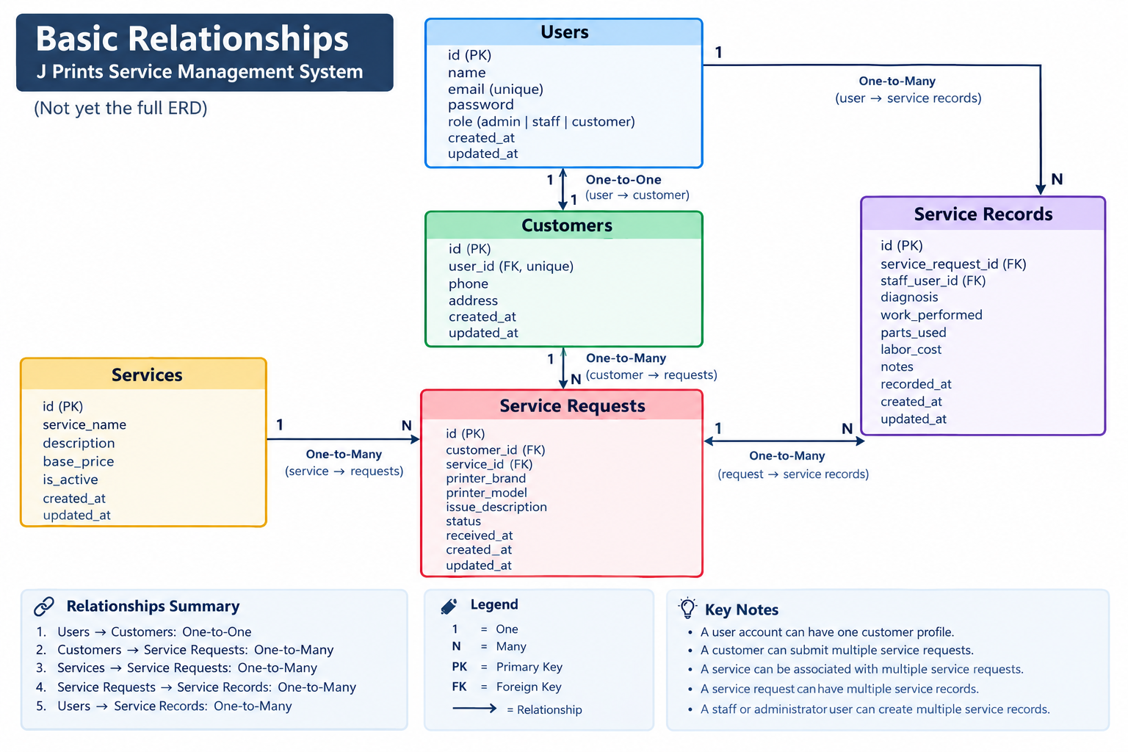
The J Prints Service Management System uses five main tables: Users, Customers, Services, Service Requests, and Service Records. These tables are connected to organize customer information, available services, repair requests, and the progress of each repair.
- Users and Customers: One user account can have one customer profile. The Users table stores login information and the user's role, while the Customers table stores additional customer information. Staff and administrator accounts do not need customer profiles.
- Customers and Service Requests: One customer can submit multiple service requests, but each service request belongs to one customer.
- Services and Service Requests: One service can be selected for multiple service requests, but each service request is associated with one service.
- Service Requests and Service Records: One service request can have multiple service records to document diagnosis, repair progress, parts used, and other service updates. Each service record belongs to one service request.
- Users and Service Records: One staff or administrator account can create multiple service records. Each record identifies the staff member who documented the service update.

Service Request Statuses
The system will use the following statuses to track each printer repair request:
- Received: The printer has been accepted by J Prints, and the request has been recorded.
- Diagnosing: The printer is being inspected to identify the problem.
- Repairing: The repair work is in progress.
- Ready: The repair is finished, and the printer is ready for collection.
- Released: The printer has been returned to the customer, completing the request.
The normal workflow is Received → Diagnosing → Repairing → Ready → Released. Authorized staff or administrators will update the request status as the repair progresses, while customers can view the status of their own requests.

Planned Features
- The application will include:
- User registration
- User login
- User logout
- Current-user authentication
- Admin and customer roles
- Customer management
- Service management
- Service request CRUD
- Service record management
- Search and filtering
- API pagination
- Admin dashboard
- Request status workflow
- Client-side validation
- Laravel Form Request validation
- Loading indicators
- Success and error messages
- Delete confirmation
- Protected React routes
- Protected Laravel API routes

